JRAHS 2005 TRIAL HSC – EXTENSION I

Question 1. [Start a new page] Marks

a) If 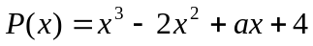 is divisible by 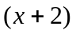, what is the value of a ? 1

b) i) Find 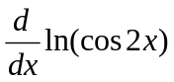 1
ii) Hence evaluate exactly  dx 2

c) Find i) 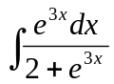 1

ii) 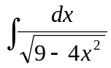 2

d) Find the acute angle between the straight lines 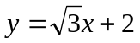 and . 2

e) Solve : 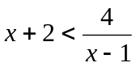 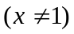 3

Question 2. [Start a new page] Marks
a) By making the substitution 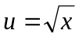 , evaluate exactly 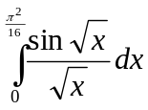 3

b) i) Sketch the graph of the curve 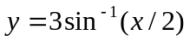, clearly indicating the domain 2
and range.

ii) Find the area enclosed between the curve , 2
the line 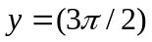 and the positive y axis.

c) The polynomial equation 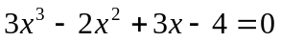 has roots 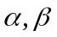 and . 2
Find the exact value of 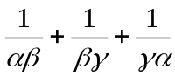 .

d) The letters of the word MOUSE are to be rearranged.

- How many arrangements are there which start with the letter M and end with 1
the letter E ?

ii) How many arrangements are there in which the vowels are grouped together? 1
(A vowel is one of the letters A, E, I, O, U)

iii) How would your answers to parts (i) and (ii) change if the given word had been 1
MOOSE instead of MOUSE ?
Question 3. [Start a new page] Marks

a) Find the general solution (in radian form) of the equation 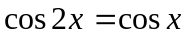 3

b) i) At the distinct points 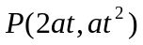and 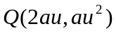on the parabola 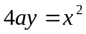,
the tangents are drawn. You may assume, without proof, that the equation
of the tangent at P is 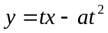. Show that the tangents from P and Q
intersect at the point 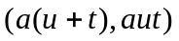. 2

- From the point R 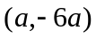, two tangents are drawn to the parabola .
If the points of contact of these tangents are P and Q, show that the
triangle PQR is isosceles. 3

c) Suppose that 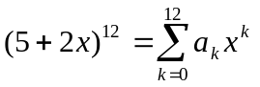.

i) Using the Binomial Theorem, write an expression for 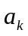. 2

ii) Show that 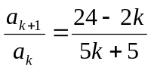 2

Question 4. [Start a new page] Marks

a) i) Sketch the function  where 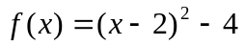, clearly 2
showing all intercepts on the axes. (Use the same scale on both axes)

- What is the largest positive domain of  for which  has a 1
continuous inverse 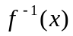 ?

iii) Sketch the graph of on the same axes as (i). 1

b) A particle moves along the x axis according to the equation
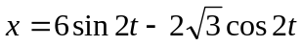.

i) Express x in the form 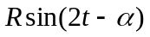 where 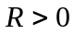 and 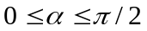. 2

ii) Prove that the particle moves in simple harmonic motion. 1

c) A,B and C are three sequential points on a straight line on horizontal ground. 5
A vertical flagpole PQ is situated close by the line (but its base P is not on the line).
The angles of elevation of the top of the flagpole from A, B and C are 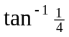, 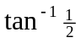
and 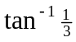 respectively. If AB = 90m and BC = 30m, find the height of t(e flagpole.
Question 5. [Start a new pa
e]
Marks

a( A particle is moving along the x-axis. Iwc velocity, v m/s at position x metres 2
iw given by
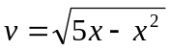.

Find dhe acceleration of the particle when 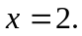

b) Prove by induction that, for any posative integer n, the product$ 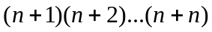
is alwa9s a multiple of 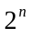 but never a multiple f 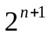. 5

c)
A

In the diagram, CQ and CP are altitudes of the triangle ABC. The lines CQ and BP
intersect at T, and AT is producud to meet CB at R.

i) Prove that 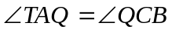. 3

ii) Prove that . 2

Question 6. YStart a new page] Marks

a) Cane sugar, when placed in water, converts into dextrose at a rate which is
proportional to the amount of unc/nverted material remaining. That is, if M
grams"is the amount of material converted after t minutes, then

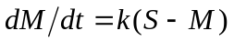

where S grams is the initial amount of cane sugar and k is a constant

i) Show that 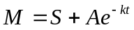 satisfies(the equation, where A is a constant. 1

ii) If a certain amount of cane sugar iS placed in water at time  and 40% 2
of it has been converted after 10 minutec, show that the value of k is
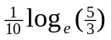.

iii) How long will it take, to the nearest minute, for 99% of the cane sugar to 2
be!Converted into dextro3e ?

(Question 6 is continued on the next pege)

M

Question 6. (Continued) Marks

b)
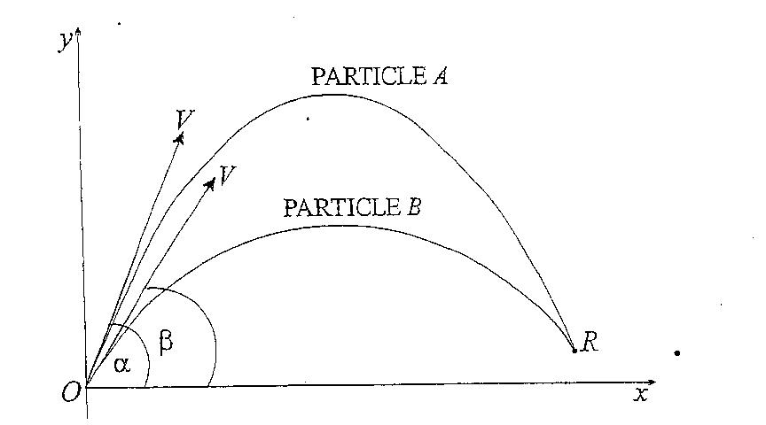

The diagram above shows two particles A and B projected from the origin.
particle A )s projected with initial velocity V m/s at an angle α and particle B is
projected T seconds later with the same initial velocity V m/s but an angle of β .
The particles collide at the point R.

- You may assume that the equation of the path of A is given by

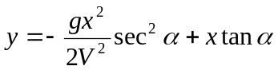

Write down the equation of the path of B. 1

Show that the x-coordinate of the collision point R is given by

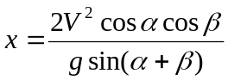 3

- You may assume that the horizontal displacement of A after t seconds
is given by
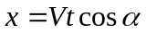

(α) Write down the equation for the horizontal displacement of B
(Remember that B is projected T seconds after A). 1

(β) Show that, for the collision to take place, the value of T is given by

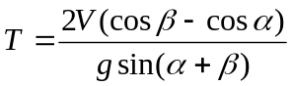 2

Question 7. [Start a new page] Marks

a) It is known that 5% of all gear boxes made in Factory A are faulty whereas 7% of 4
gear boxes made in Factory B are faulty. If 120 gear boxes are bought, 10 from each
factory, what is the probability that exactly two are faulty ?

b) i) By rotating the circle 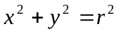 about the x axis between appropriate limits,
show that the volume V of a spherical cap of height h, as shown in Figure 1,
is given by
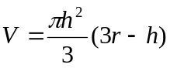 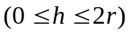 3
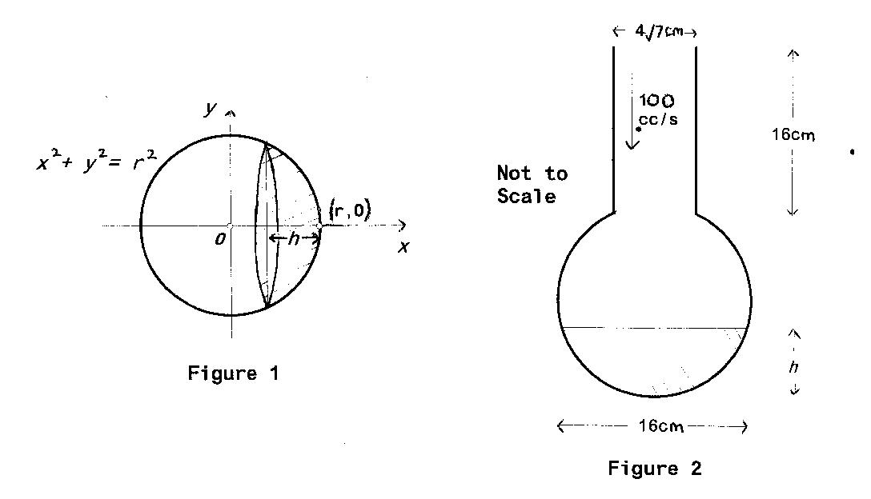
A chemical flask is modeled by surmounting an open cylinder on a thin spherical
shell (with a matching circular opening at the top). See Figure 2.

ii) The body of the flask is of radius 8cm. The neck has radius 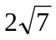cm. and 1
height 16cm. Show that the total height of the flask is 30cm.

iii) Water is poured into the flask at a constant rate of 100 cm³/sec. 2
If h is the depth of the water in the flask, use the result from part (i)
to find an expression (in terms of h) for the rate at which the water level
rises in the spherical portion of the flask.

iv) Find this rate at the instant when the water level reaches the base of 2
the cylinder and hence, or otherwise, calculate how long it will take
(from that point in time) to overflow the flask. Give your answer to
the nearest second.
THIS IS THE END OF THE EXAMINATION

